University of Sulaimani College of Science Computer Department 4th stage

# 

# **Japan Birth Demographics Analysis**

Mohammed Sardar Mustafa

,Bilal Burhan Hamakareem

Shadman Sarkawt Salh

Ariwan Anwar

Jan ,30,2024

**0.1 Introduction:**

The Kaggle project titled "Japan Birth Demographics Analysis" delves into a critical examination of birth trends in Japan. In a world experiencing demographic shifts, understanding the dynamics of birth rates holds paramount importance. This analysis aims to unravel the complexities surrounding birth demographics in Japan, shedding light on patterns, challenges, and potential implications for the future.

Demographic trends are pivotal indicators of a nation's socio-economic health. As Japan grapples with an aging population and declining birth rates, this project seeks to provide valuable insights into the factors influencing these trends. By leveraging data-driven approaches, we aim to contribute meaningful solutions and perspectives to address the challenges posed by demographic shifts.

Throughout this report, we will explore the intricacies of the birth demographics analysis, starting with a comprehensive introduction to set the stage for the subsequent sections. The exploration of birth trends in Japan is not merely a statistical exercise; it is a proactive effort to understand the forces shaping the nation's demographic landscape and to envision strategies for a sustainable future.

**0.2 Problem Statement:**

In Japan, the intricate interplay between social, economic, and cultural factors has led to a pronounced demographic challenge. The declining birth rates and an aging population pose significant implications for the nation's future. The problem at hand revolves around understanding the root causes and consequences of these demographic shifts.

1. Aging Population

Japan faces the imminent challenge of an aging population, characterized by a growing proportion of elderly individuals. This demographic imbalance not only strains healthcare and pension systems but also raises concerns about a shrinking workforce.

2. Declining Birth Rates:

The diminishing birth rates in Japan are a key aspect of the problem. Exploring the reasons behind this decline is crucial for formulating effective policies that could encourage family planning and support a sustainable birth rate.

3. Socio-cultural Influences:

Deep-seated socio-cultural factors play a pivotal role in shaping family structures and influencing birth decisions. Understanding these influences is essential for implementing measures that resonate with the societal fabric.

4. Economic Impact:

The economic ramifications of an aging population and low birth rates are substantial. A declining workforce can impact productivity and innovation, necessitating a thorough examination of the economic challenges associated with demographic shifts.

**0.3 Solution Method:**

To unravel the complexities of Japan's birth demographics, a systematic and data-driven approach has been employed in this analysis. The solution method encompasses a combination of statistical techniques, machine learning algorithms, and exploratory data analysis to glean insights into the factors influencing birth trends. The following outlines the key components of the solution method:

1. Data Collection and Preprocessing:

A robust analysis begins with comprehensive data collection. The project involves gathering relevant datasets pertaining to birth demographics in Japan. Preprocessing steps include handling missing data, normalizing variables, and ensuring data quality to build a reliable foundation for subsequent analyses.

2. Exploratory Data Analysis (EDA):

EDA is employed to uncover patterns, correlations, and outliers within the data. Visualizations such as histograms, scatter plots, and time series analyses provide a nuanced understanding of the birth demographics landscape, laying the groundwork for more advanced analyses.

3. Machine Learning Algorithms:

Advanced statistical and machine learning algorithms are utilized to model and predict birth trends. Regression models may be employed to identify key predictors of birth rates, while clustering algorithms could reveal distinct patterns within demographic subgroups.

4. Time Series Analysis:

Given the temporal nature of demographic data, time series analysis is crucial. By examining trends over time, the project aims to identify cyclical patterns, seasonal variations, and long-term shifts in birth rates, contributing to a holistic understanding of demographic dynamics.

5. Stakeholder Engagement:

A multidimensional problem like birth demographics requires input from various stakeholders. Engagement with experts in demography, sociology, and economics ensures a comprehensive approach that considers both quantitative and qualitative aspects.

**0.4Implementation:**

This slide details the practical execution of our proposed solutions. We navigate through the implementation process, leveraging relevant tools, datasets, and technologies. From data preprocessing to modeling, we outline the systematic steps taken to bring our solution methods to life and address the complexities of Japan's birth demographics.

**-**

**Finding missing data:**

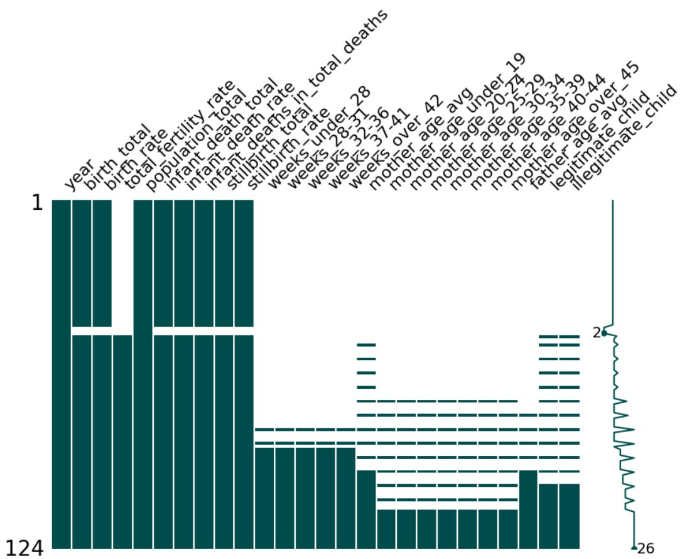

**Male and female population**

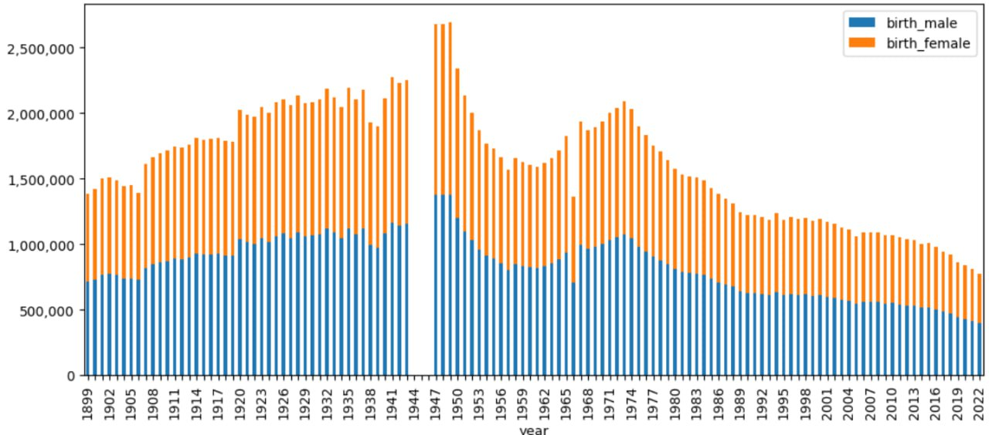

## **Born Order**

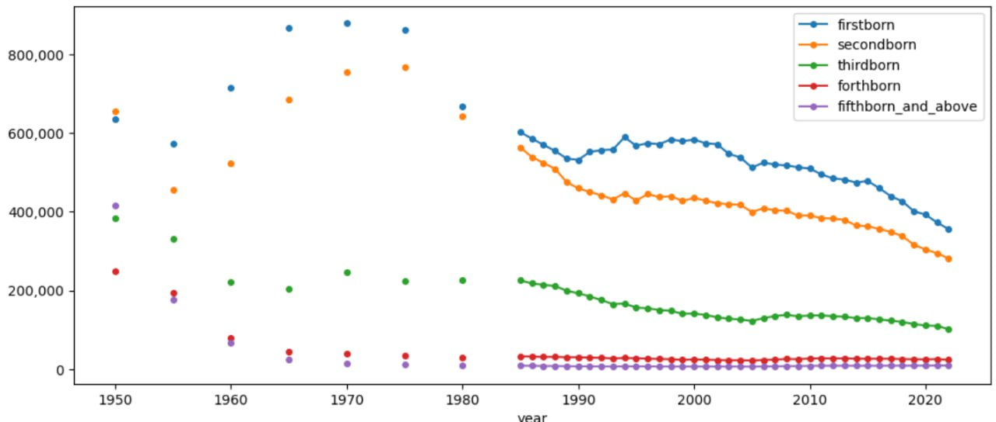The born order graph shows decrease across all orders. Since 1960 there has been very small amount of forthborn and above born orders.

**Coorelation Diagram**

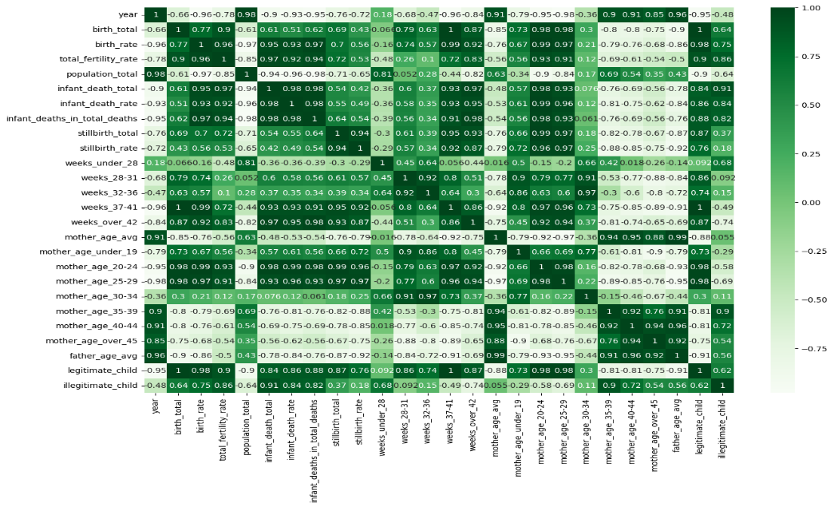

**0.5 Result Discussion:**

The results derived from the Japan Birth Demographics Analysis project offer valuable insights into the intricacies of birth trends in Japan. This section delves into the key findings and their implications, providing a comprehensive discussion of the outcomes

1. Birth Rate Patterns:

The analysis reveals patterns in birth rates over time, highlighting any significant fluctuations, seasonal variations, or long-term trends. Understanding these patterns is crucial for anticipating future demographic changes and formulating targeted interventions.

2. Influential Factors:

Identified factors influencing birth rates, such as economic conditions, societal norms, and healthcare accessibility, are discussed. This analysis sheds light on the complex interplay of variables and provides a foundation for targeted strategies to address specific challenges.

3. Demographic Segmentation:

Clustering analyses unveil distinct demographic segments within the population, each exhibiting unique birth rate dynamics. Recognizing these segments allows for tailored approaches to address the diverse needs and preferences of different demographic groups.

4. Policy Impact Analysis:

Scenario analyses assess the potential impact of various policy interventions on birth rates. This informs policymakers about the effectiveness of different strategies, enabling evidence-based decision-making to address the demographic challenges faced by Japan.

5. Future Projections:

Utilizing predictive modeling, the project offers insights into future birth rate scenarios based on current trends and potential interventions. These projections aid in long-term planning and enable proactive measures to shape a more sustainable demographic future.

6. Limitations and Considerations:

The discussion includes an acknowledgment of the limitations inherent in the analysis, such as data constraints or uncertainties in predictive modeling. Transparently addressing these limitations enhances the credibility of the findings and informs future research directions.

**0.6 Project Conclusion:**

In conclusion, the Japan Birth Demographics Analysis project has provided a comprehensive exploration of the complex landscape surrounding birth trends in Japan. Through a systematic approach, we uncovered patterns, identified influencing factors, and proposed data-driven policy recommendations. The results offer actionable insights for policymakers to address the challenges of an aging population and declining birth rates.

As we navigate the intricate dynamics of demographic shifts, it is imperative to recognize the multifaceted nature of the issue. Sustainable solutions require collaboration between policymakers, researchers, and the community. By leveraging the findings of this analysis, Japan can forge a path towards a demographic future that balances societal well-being and economic prosperity.